VE Day and World War 2 Activities– Year 5 and Year 6
These activities help you to discover more about VE Day and World War 2.
Understanding World War Two  On 8 May 1945 Britain celebrated the end of World War Two. To understand why VE Day was so important, you need to understand WW2. Research what happened during WW2.  When did it start?  Why did it start? Who fought?  Where did fighting take place?  What happened during the Battle of Britain?  What happened on D-Day? What was rationing?  What was evacuation?  What happened during the Blitz?  You may present this information in any way you choose.  https://www.bbc.co.uk/bitesize/guides/z9s9q6f/revision/1 |  | 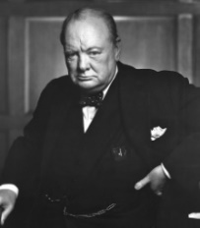  Research Winston Churchill  Winston Churchill was the Prime Minister in 1945. Research and make a fact file about who Churchill was. Consider why he was important, his personality, his family, his hobbies and his jobs.
Postcard task  Write a ‘Postcard from the Past’. Imagine you were at the first VE day and heard the news that the war had ended.  What might you tell your family about what you heard? What did you do? Who else was there?  What decorations were made and hung up? Use the link below find out more about VE Day  https://www.bbc.co.uk/teach/class-clips-video/history-ks2-ve-day/z7xtmfr  https://www.bbc.co.uk/teach/ve-day-How-did-the-british-plan-to-celebrate/zndn7nb | Flag task  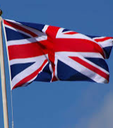  During World War Two, countries that were part of the British Empire fought alongside the British. Some of these countries were: Canada, USA, Bermuda, Jamaica, The Bahamas, Australia, New Zealand, Kenya, Mauritius, Seychelles, Trinidad and Tobago, India and Cyprus. Find and draw the flags for these countries.  Can you find other countries that fought alongside the British in WW2 and find and their flags too? | 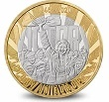  Design your own VE coin or medal  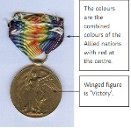  8 May 1945, now known as VE Day, saw the beginning of the end of the Second World War – the conflict that claimed the lives of millions and reshaped the future of countries and continents. The Royal Mint have designed a commemorative coin to remember VE Day. Your task is to design your own commemorative coin or a VE Day medal. You could think about the following ideas when designing yours: the years of the war; the colours of the ally flags or a reference to how the war was fought (land, air and sea).
Remembering VE Day in Crawley  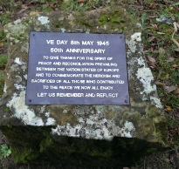  In lots of locations around the UK there are memorials to World War 1 and World War 2.  “Let us remember and reflect”.  Now we are celebrating the 75th anniversary, design your own memorial plague and write your own message on your plague. | Music    VE Day Songs  Try and learn the Horrible Histories VE Day song and perform it to your family.  Create your own motivational song. Listen to some of the following clips for inspiration. Click below to listen to some more traditional war time songs as well as the links below.  Long way to Tipperary/ Pack up your troubles  We’ll meet again  The White Cliffs of Dover  - Learn step-by-step how to Swing dance (The Lindy Hop) which originated in the late 1920s and early 1930s in Harlem, New York City. | VE reflections  Now you know more about VE Day, answer these questions to sum up your learning on VE Day.  - Why do you think it is important to celebrate and recognise VE Day?  - How do you think VE Day should be celebrated in the future?

